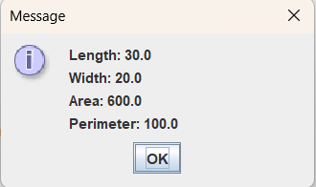
package as1;

import javax.swing.JOptionPane;

public class Rectangle {

public static void main(String[] args) {
String in, out;
double l, w;
double area, perim;

in=JOptionPane.showInputDialog ("Enter length");
l=Double.parseDouble (in);

in=JOptionPane.showInputDialog ("Enter width");
w=Double.parseDouble (in);

//call method computeArea to find area
area = computeArea (l, w);

//write code below to call method computePerim
perim = computePerim (l, w);

//build output string using string concatenation

out="Length: " + l + "\n";
out= out + "Width: " + w + "\n";
out= out + "Area: " + area + "\n";
out= out + "Perimeter: " + perim + "\n";

JOptionPane.showMessageDialog (null, out);

}

public static double computeArea (double length, double width)

{
double area=0;
area = length * width;
return area;
}

public static double computePerim (double length, double width)

{
double perim=0;
perim = 2*length + 2*width;
return perim;

}

}

